Software Design Specification
for
Project Marauders
Version 1.0
Prepared by: Sreedevi Reddy , Charlu Sowmya, Christian Mahima, Akarsh , Apoorva Garg
(B.TECH, V SEM)
Date Created: October 28, 2016
Table of Contents
Table of Contents ii
Revision History ii
1. Introduction
1.1 Purpose
1.2 Scope
1.3 Definitions, acronyms, and abbreviations
1.4 References
1.5 Overview of document
2. System architecture description
2.1 Overview of modules / components
2.2 Structure and relationships
2.3 User interface issues
3. Detailed description of components
3.1 Component template description
4.0 Reuse and relationships to other products
5.0 Design decisions and tradeoffs
6.0 Pseudocode for components

Revision History
Name | Date | Reason For Changes | Version

1. Introduction

  - Purpose of this document
The Software Design Document is a document to provide documentation which will be used to aid in software development by providing the details for how the software should be built. Within the Software Design Document are narrative and graphical documentation of the software design for the project including use case models, sequence diagrams, collaboration models, object behaviour models, and other supporting requirement information.

1.2 Scope of the development project
Scope of the project is to design and develop the Employee Engagement Web Application that will be wrapped using PhoneGap to deploy onto IOS and Android platforms.

1.3 Definitions, acronyms, and abbreviations
Apache: This is the most used web server, we will be using his as our server to establish connections between the front and he back ends.
AWS: Amazon web services, they offer cloud computing services.
FTP: File transfer protocol a standard network protocol used to transfer computer files between the client and the server on a computer network.
HTTP: Hypertext transfer protocol is a structured text that uses logical links i.e. hyperlinks between nodes containing texts.
MySQL: It is an open source relational database management system, which will be used in our project to store user ids and passwords.
PhoneGap: it’s a framework that we will be using to develop our application. Encryption: to protect user data.
User: An employee or manager of the organization.
Xampp: Web server solution stack package.
Organization: Popcorn apps.
1.4 References
http://www.slideshare.net/supriyasjbit/employee-management-system1
http://dl.acm.org/citation.cfm?id=1499854
https://www.scribd.com/doc/27264009/Design-Document-for-library-management- system
https://www.scribd.com/doc/27264009/Design-Document-for-library-management-system
https://www.google.co.in/?gfe_rd=cr&ei=W4sTWMC8LKHR8AeljoH4Cw

1.5 Overview of document
The Software Design Document is divided into 11 sections with various subsections. The sections of the Software Design Document are:
1 Introduction
2 Glossary
3 Use Cases
4 Design Overview
5 System Object Model
6 Object Descriptions
7 Object Collaborations
8 Data Design
9 Dynamic Model
10 Non-functional Requirements

2. System architecture description
2.1 Overview of modules / components
Our system is broken up into two major components i.e. a client side web application and a server side PHP application and MySQL database. Our frontend is being done using HTML, CSS, JAVASCRIPT, JQUERY and Ajax, whereas our backend s being handled by Apache server ,PHP and a MySQL database software and our GUI i.e. the graphical component is handled by PHP.
The server component is comprised of Apache which manages incoming and outgoing messages and we have a MySQL database which provides centralized storage for synchronized data.

2.2 Structure and relationships
State diagram followed by sequence diagrams.

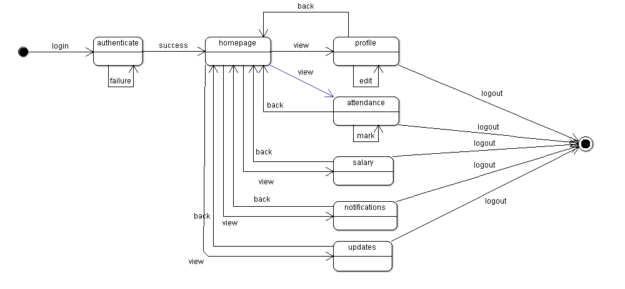
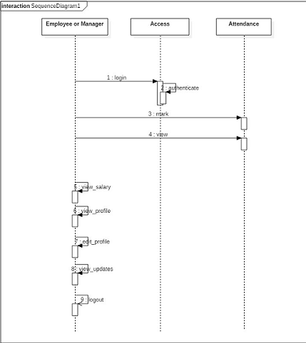

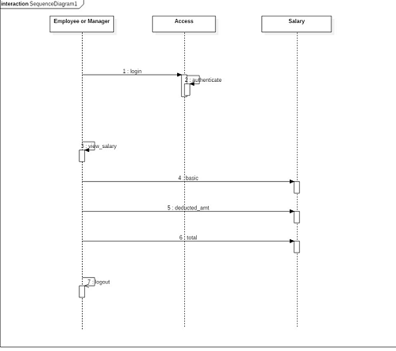
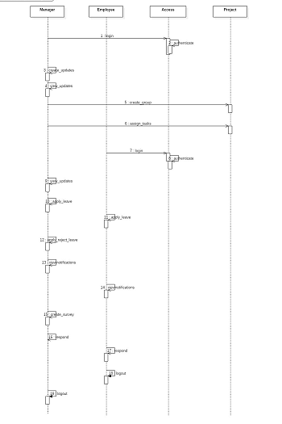

2.3 User interface issues

This is maintained as user friendly as possible. However, a lot of priority has been given to avoid third party and not genuine plugins to avoid any issues which could cause any unauthorized access or hampering of data. The work flow of the software is also in sync with the functionalities listed. However, for any user to access the information, a login page will be in its rightful place. The software is so designed to inform the user on his/her mobile phone via a message if the account of the specific user has been tried to access with wrong pass codes 3 times in a row.

3. Detailed description of components
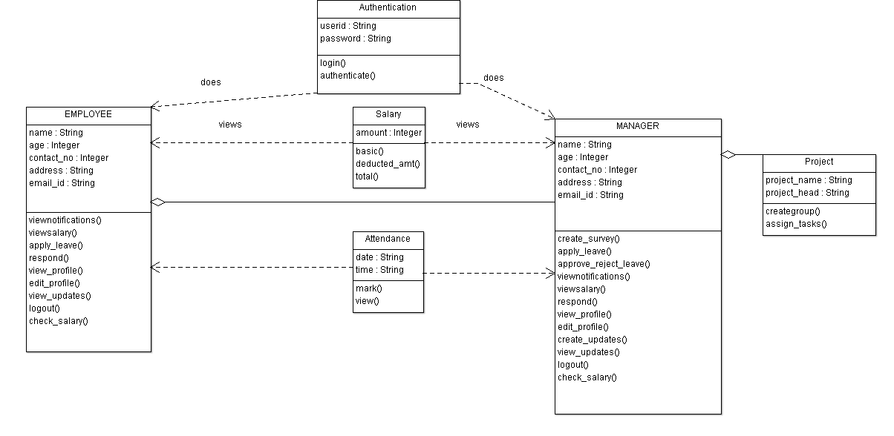

3.1 Component template description
Component 1
Identification | Access, the first interface an user will see.
Type | Class
Purpose | It gives access to the application.
Function | It will give access to the application. An user will have to login i.e. input his/her userid and password which will be authenticated by checking with the database and on receiving success will give access to the homepage. Also, the user must specify if he/she is an employee or a manager.
Subordinates | The functional components are login() and authenticate().
Dependencies | Any user must specify whether they are an employee or a manager which in themselves are components and depend on “access” component for further transactions. Without this the future actions, cannot take pace.
Interfaces | The details entered by the user will be authenticated by comparing the values present in the databases, if respective parameters fail to match and an error will be generated and the passwords are protected using encryption techniques. If an user enters the password incorrectly thrice then an error message will be sent to the contact number of the user.
Resources | We need an OS, processing power, memory, monitor, keyboard, mouse and a web browser and a platform to run the software on.
Processing | Login(): will accept the userid and password in string format  The user will select manager/employee.  Authenticate(): The values entered in login will be passed as parameters and then will be compared with values present in the database.  If true return 1  Else return 0.
Data | Userid and password, both are accepted in string format and will be represented as text boxes in GUI

Component 2

Identification | Employee: if the user chooses employee and enters the correct userid and password he/she will be taken to thwir homepage.
Type | Class
Purpose | It gives access to the homepage and allows users to perform or choose from a variety of actions like:  - View profile  - View attendance  - Mark attendance  - View salary  - View notifications  - Apply for leave  - View project updates  - Logout
Function | Function of this particular class provides the user with a variety of activities to choose from and keep one engaged and motivated with work. The specific inputs that are processed are name, position, salary, projects done and all of this is stored in a database
Subordinates | The functional components are:  - Viewnotifications()  - Viewsalary()  - Apply_leave()  - Respond()  - View_profile()  - Edit_profile()  - View_updates()  - Logout()
Dependencies | If an employee applies for leave he/she has to wait for the manager to approve or reject the application and likewise an employee can only view updates, news posted by the manager and not make changes. An employee can only view or respond to polls but cannot create one.
Interfaces | If an employee choose previous date to apply for leave then the system will generate an error.
Resources | We need an OS, processing power, memory, monitor, keyboard, mouse and a web browser and a platform to run the software on.
Processing | - Viewnotifications():on clicking this button the current notifications will be displayed.  - Viewsalary():on clicking this button the current salary will be displayed  - Apply_leave():on clicking this button one can apply for leave.  - Respond():on clicking this one can respond to polls  - View_profile():on clicking this button one can view profile.  - Edit_profile():on clicking this one can edit profie  - View_updates():on clicking this button the current updates will be displayed  - Logout():on clicking this button one can logout.
Data | All of these are in button format and the user will be redired to respective pages using PHP.

Component 3
Identification | Manager: if the user chooses employee and enters the correct userid and password he/she will be taken to thwir homepage.
Type | Class
Purpose | It gives access to the homepage and allows users to perform or choose from a variety of actions like:  - View profile  - View attendance  - Mark attendance  - View salary  - View notifications  - Apply for leave  - View project updates  - Logout  - Approve/reject leave  - Create updates
Function | Function of this particular class provides the user with a variety of activities to choose from and keep one engaged and motivated with work. The specific inputs that are processed are name, position, salary, projects done and all of this is stored in a database
Subordinates | The functional components are:  - Viewnotifications()  - Viewsalary()  - Apply_leave()  - Respond()  - View_profile()  - Edit_profile()  - View_updates()  - Logout()  - Approve/reject leave()  - Create_updates()
Dependencies | If an employee applies for leave he/she has to wait for the manager to approve or reject the application and likewise an employee can only view updates, news posted by the manager and not make changes. An employee can only view or respond to polls but cannot create one.
Interfaces | If an employee choose previous date to apply for leave then the system will generate an error.
Resources | We need an OS, processing power, memory, monitor, keyboard, mouse and a web browser and a platform to run the software on.
Processing | - Viewnotifications():on clicking this button the current notifications will be displayed.  - Viewsalary():on clicking this button the current salary will be displayed  - Apply_leave():on clicking this button one can apply for leave.  - Respond():on clicking this one can respond to polls  - View_profile():on clicking this button one can view profile.  - Edit_profile():on clicking this one can edit profie  - View_updates():on clicking this button the current updates will be displayed.  - Approve_rejectleave(): the manager can approve or reject the leave application by an employee with a specific reason for rejecting the application.  - Create_updates(): the manager creates updates and polls along with surveys for the company employees to fill it.  - Logout():on clicking this button one can logout.
Data | These are in button format and the user will be redirected to respective pages using PHP.

Component 4

Identification | Project.
Type | Class
Purpose | It gives access to the project details of the ongoing project and all the group members and the project head. Basically, the manager creates a project group and assigns a head along with the tasks.  - Create group  - Assign_tasks
Function | Function of this class particularly belongs to the manager class since that is the position assigning projects and tasks. This class tell the user who are a part of the project, the project head and the assigned tasks.
Subordinates | The functional components are:  - Create_group()  - Assign_tasks()
Dependencies | The manager class and this class are dependent on each other because a manager is the person assigning projects.
Interfaces | Not applicable.
Resources | We need an OS, processing power, memory, monitor, keyboard, mouse and a web browser and a platform to run the software on.
Processing | - Viewnotifications():on clicking this button the current notifications will be displayed.  - Viewsalary():on clicking this button the current salary will be displayed  - Apply_leave():on clicking this button one can apply for leave.  - Respond():on clicking this one can respond to polls  - View_profile():on clicking this button one can view profile.  - Edit_profile():on clicking this one can edit profile  - View_updates():on clicking this button the current updates will be displayed  - Logout():on clicking this button one can logout.  - Create_group: on clicking this button many employees can be added to a project group.  - Assign_tasks(): On clicking this button the manager can assign tasks by providing the required description.
Data | These are in button format and the user will be redirected to respective pages using PHP.

Component 5

Identification | Salary
Type | Class
Purpose | The purpose of this class is to allow users to view their salary status and decide for themselves where the salary has been deducted.
Function | Function of this class is to display the salary of every employee based on the number of days the employee worked. It includes functions where the user can check their basic salary and the total amount and the deducted amount.
Subordinates | The functional components are:  - Basic salary  - Deducted amount  - Total salary
Dependencies | The salary class depends on the attendance class because the salary s calculated based on the number of present days the employee has worked for including the paid holidays.
Interfaces | Here errors in the calculation of the salary may arise due to human or technical faults.
Resources | We need an OS, processing power, memory, monitor, keyboard, mouse and a web browser and a platform to run the software on.
Processing | - Basic_salary(): Here the user can check their monthly/annual salary.  - Deducted_amount(): The amount deducted including the taxes as well as the number of absent days excluding the paid leaves.  - Total_salary():: The total salary for the month inclusive of all the deductions.
Data | These are in button format and the user will be redirected to respective pages using PHP.

Component 6

Identification | Attendance: to mark or view attendance.
Type | Class
Purpose | It allows the user to check his/her attendance or mark attendance.
Function | Function of this particular class is that one can view attendance using any network but for any user to mark his/her attendance he/she has to login using the organizations network and this will be done matching the IP address of the network.
Subordinates | The functional components are:  - Mark()  - View()
Dependencies | One must be logged on to the application using the organization’s network to mark their attendance ese it will generate some error.
Interfaces | If an employee chooses previous date to mark attendance it will generate an error and a notification will be sent to the respective manager.
Resources | We need an OS, processing power, memory, monitor, keyboard, mouse and a web browser and a platform to run the software on.
Processing | - Mark():on clicking this button ,match the IP address and then will be allowed to mark for the present day.  - View():on clicking this button one can see their attendance status..
Data | This is in button format.

4.0 Reuse and relationships to other products
The project that we are doing is an employee engagement application, and since it could be further updated with newer version, the modules present currently in our class can be reused. Currently we are not reusing any older versions for any module. However, the modules that we are creating and using can be used by other developers for future endeavors.

5.0 Design decisions and tradeoffs
Initially it was decided we would Employee and manager as classes with their super class being user but since there was nothing an employee could do that a manager could not we removed the superclass and used an associative relation between Manager and Employee classes.
We chose to keep salary as a separate class as it uniquely checks every detail and processes the data. Since every project is created by a manger and then the manager assigns these projects to respective employees, the class Project was considered as an exclusive class of Manager.
6.0 Pseudocode for components
Access:
- Start-up system.
- Enter username and password.
- Choose employee/manager.
- On clicking the login button connect to database.
- Check in database using queries to see if the entered values are correct or not.
- If yes, go to homepage.
- Else failure.

Manager
- An user who is a manager upon login success will be directed here.
- Can choose from the many options available.
- logout

Employee
- An user who is an employee upon login success will be directed here
- Can choose from the many options available.
- logout
Project
- A manager creates project
- Check skill set of employees in database.
- Return names of matching employees.
- User chooses the ones he/she needs.
- User decides project head.
- Send notifications to the chosen employees.
- Employee checks notifications.
Leave Application
- Click on button
- Redirect to application page.
- Fill in required details
- If all are filled
- Check manager and send notification
- Manager views
- If rejected set value to 0 and send to employee
- Else set to 1 and send to employee.
- Employee receives notification.
Salary
- User clicks the button
- Retrieve details of user from the database
- Calculate salary which will be awarded.
- Display as popup.

7.0 Appendices (if any)
NOT APPLICABLE

